Wastage Solutions

## A PROJECT REPORT

**Submitted By**

## VISHESH GUPTA (2100290140152) AKASH PANDEY (2100290140012) SURYANSH PANDEY (2100290140139) AMAN SINHA (2100290140021)

**Submitted in partial fulfilment of the Requirements for the Degree of**

MASTER OF COMPUTER APPLICATIONS

## Under the Supervision of

**Ms. Divya Singhal Assistant Professor**



**Submitted to**

**DEPARTMENT OF COMPUTER APPLICATIONS**

## KIET Group of Institutions, Ghaziabad Uttar Pradesh-201206

**(FEB 2023)**

# CERTIFICATE

Certified **Vishesh Gupta 2100290140152, Akash Pandey 2100290140012, Suryansh Pandey 2100290140139, Aman Sinha 2100290140021** has/ have carried out the project work having “Wastage **Solutions**” for Master of Computer Applications from Dr. A.P.J. Abdul Kalam Technical University (AKTU**)** (formerly UPTU), Technical University, Lucknow under my supervision. The project report embodies original work, and studies are carried out by the student himself / herself and the contents of the project report do not form the basis for the award of any other degree to the candidate or to anybody else from this or any other University/Institution.

### Date:

**Vishesh Gupta (2100290140152)**

### Akash Pandey (2100290140012)

**Suryansh Pandey (2100290140139)**

### Aman Sinha (2100290140021)

This is to certify that the above statement made by the candidate is correct to the best of my knowledge.

Date:

Ms. Divya Singhal

### Assistant Professor

**Department of Computer Applications KIET Group of Institutions, Ghaziabad**

### Signature of Internal Examiner Signature of External Examiner

**Dr. Arun Tripathi**

**Head, Department of Computer Applications KIET Group of Institutions, Ghaziabad**

# ABSTRACT

We aim to provide solutions for wastage in an E-fashion. The goal is to reduce the wastage in a modern manner on fingertips.

In this project we would provide a service in which the people can register with essential details and can login with same details. After that they can select the categories of wastage and submit it.

One of our garbage collectors will reach the location and directly take it to the landfills and in landfills we will get money on market price, which further will be used to send the coupons of different shopping and commercial sites.

The basic idea is to connect all the nearby wastage and provide it to the garbage collector so that there will be less chaos on the roadside, and we will provide a reward coupon to them.

Collector: There will be a group of people who will collect the garbage to their respective locations and take it to the landfills.

User: User can register and provide the details of their wastage with following categories mentioned on the site.

Supervisor: The admin as a supervisor can view the total no of actions performed on all the modules. (Number of coupons sold, number of wastages thrown, total money earned etc.)

# ACKNOWLEDGEMENTS

Success in life is never attained single handedly. My deepest gratitude goes to my thesis supervisor **Ms. Divya Singhal,** Assistant Professor, for his guidance, help and encouragement throughout my research work. Their enlightening ideas, comments, and suggestions encouraged me to complete this project.

Words are not enough to express my gratitude to **Dr. Arun Tripathi**, Professor and Head, Department of Computer Applications, for his insightful comments and administrative help at various occasions.

Fortunately, I have many understanding friends and team members, who have helped me a lot on many critical conditions.

Finally, my sincere thanks go to my family members and all those who have directly and indirectly provided me moral support and other kind of help. Without their support, completion of this work would not have been possible in time. They keep my life filled with enjoyment and happiness.

**Vishesh Gupta Akash Pandey Suryansh Pandey Aman Sinha**

# TABLE OF CONTENTS

|  |  |  |  |
| --- | --- | --- | --- |
| Certificate | | | ii |
|  | Abstract | | iii |
|  | Acknowledgements | | iv |
|  | Table of Contents | | v – vi |
|  | List of Abbreviations | | vii |
|  | List of Tables | | viii |
|  | List of Figures | | ix – x |
| 1 | Introduction | | 1- 3 |
|  | 1.1 | Project description | 1 |
|  | 1.2 | Project Scope | 1 |
|  | 1.3 | Hardware / Software used in Project | 2 - 3 |
|  | 1.4 | Functional Requirements | 3 |
|  | 1.5 | Non - Functional Requirements | 3 - 4 |
| 2 | Feasibility Study | | 5 - 7 |
|  | 2.1 | Technical feasibility | 5 |
|  | 2.2 | Operational Feasibility | 6 |
|  | 2.3 | Behavioral Feasibility | 6 - 7 |
|  | 2.4 | Economic Feasibility | 7 |

|  |  |  |
| --- | --- | --- |
| 3 | Database Design | 8 – 15 |
|  | 3.1 Flow Chart Diagram | 8– 9 |
|  | 3.2 Database Tables | 9 – 11 |
|  | 3.3 Entity Relationship Diagram | 12 – 13 |
|  | 3.4 Use Case Diagram | 13 – 14 |
|  | 3.5 Sequence Diagram | 14 – 15 |
| 4 | Form Design | 16 – 17 |
|  | 4.1 Landing Page | 16 |
|  | 4.2 Login Page | 16 -17 |
|  | 4.3 Add Request Page | 17 |
|  | 4.4 View request Status | 18 |
| 5 | Coding | 19 – 42 |
| 6 | Testing | 40 - 45 |
|  | 6.1 Testing Case 1 (Login) | 43 |
|  | 6.2 Testing Case 2 (Add Products) | 44 |
|  | 6.3 Testing Case 5 (Logout) | 45 |
| 7 | Literature Review | 46-47 |
| 8 | Bibliography | 48 |

**List of Abbreviations**

|  |  |  |  |
| --- | --- | --- | --- |
| **S No.** | **Name of Abbreviations** | **Details of Abbreviations** | **Page** |
| 1 | CS | Computer Science | 1 |
| 2 | OS | Operating System | 1 - 2 |
| 3 | Database Tables | Database Tables | 9 -11 |
| 4 | ER | Entity Relationship | 12 |
| 5 | UCD | Use Case Diagram | 13 |
| 6 | SD | Sequence Diagram | 14 |

# LIST OF TABLES

|  |  |  |
| --- | --- | --- |
| **Table No.** | **Name of Table** | **Page** |
| 2.1 | Admin Table | 7 |
| 2.2 | Contact us | 8 |
| 5.1 | Coupons | 8 |
| 5.2 | Request | 9 |
| 5.3 | Users | 9 |

**LIST OF FIGURES**

|  |  |  |
| --- | --- | --- |
| **Figure No.** | **Name of Figure** | **Page No.** |
| 3.1 | Flow Chart Symbols | 8 |
| 3.2 | Flow Chart Diagram | 9 |
| 3.3 | Database Tables | 9 |
| 3.4 | Entity Relationship Diagram | 12 |
| 3.5 | Use Case Diagram | 13 |
| 3.6 | Sequence Diagram | 14 |
| 4.1 | Landing Page | 16 |
| 4.2 | Login Page | 16 |
| 4.3 | Add Request | 17 |
| 4.4 | View Request | 18 |
| 6.1 | Test Case 1 (Login) | 43 |
| 6.2 | Test Case 2(Add Request) | 44 |
| 6.3 | Test Case 3(Logout) | 45 |

# Chapter 1

# Introduction

* 1. **Project description**
     + We aim to provide solutions for wastage in an E-fashion. The goal is to reduce the wastage in a modern manner on fingertips.
     + In this project we would provide a service in which the people can register with essential details and can login with same details.
     + One of our garbage collectors will reach the location and directly take it to the landfills and in landfills we will get money on market price, which further will be used to send the coupons of different shopping and commercial sites.
     + The basic idea is to connect all the nearby wastage and provide it to the garbage collector so that there will be less chaos on the roadside, and we will provide a reward coupon to them.
     + Collector: There will be a group of people who will collect the garbage to their respective locations and take it to the landfills.
     + User can register and provide the details of their wastage with following categories mentioned on the site.
     + Supervisor: The admin as a supervisor can view the total no of actions performed on all the modules. (Number of coupons sold, number of wastages thrown, total money earned etc.).

# Project Scope

The proposed system will focus on maintenance of sanity in the environment and preventing pollution that might result in severe health complications to the inhabitants of the areas where garbage and environment conservation is not put into consideration.

# Hardware / Software used in Project

## Software Requirement for development

System Software –

* + - * Operating System (Windows XP or above)
      * Server (TOMCAT Server) Application Software –
        + Database (MySQL)

Web Technologies-

* + - * HTML5 & CSS3
      * Bootstrap
      * JavaScript

Frameworks

* + - * Spring

## Software Requirement for User

OS –

* + - * Windows XP or above

Web Browser-

* + - * Microsoft Edge or above

## Hardware Requirement for development

* + - * **Input Devices -** All basic input devices like keyboard, mouse,etc.
      * **Output Devices -** All basic output devices likeprinter, monitor, etc.

### Secondary storage devices -

* + - * + HDD - 60GB or above.
        + Back-up - Flash Drive, CD/DVD, cloud storage etc.

### Internal components -

* + - * + RAM - 512 MB (Minimum)
        + Processor - Intel Pentium 4 Processor or above

### Hardware Requirement for User

* Input Devices - All basic input devices like keyboard, mouse, etc.
* Output Devices - All basic output devices like printer, monitor, etc.
* Stable and secure Internet connection

# FUNCTIONAL REQUIREMENTS

### Request System-

* Create an Account
* Login to the Website
* Navigate to the Dashboard.
* Fill the Request Form
* Customized the Request

### Request Management System-

* Add a new/update/delete request
* See the status of the request
* View the coupons
* Update the status of the request

# NON- FUNCTIONAL REQUIREMENTS-

* **Portability** System running on one platform can easily be converted to run on another platform.
* **Reliability** The ability of the system to behave consistently in a user- acceptable manner when operating within the environment for which the system was intended.
* **Availabilit**y The system should be available at all times, meaning the user can access it using a web browser, only restricted by the down time of the server on which the system runs.
* **Maintainability** A commercial database is used for maintaining the database and the application server takes care of the site.
* **Security** Secure access of confidential data.

# Chapter 2 Feasibility Study

## 2.1 Technical feasibility-

It is the complete study of the project in terms of input, processors, output, fields, programs and procedure. It is a very effective tool for long term planning and troubleshooting. Technical feasibility is a process of validating the technology assumptions, architecture and design of a product. The following are common types of technical feasibility.

### Concepts

Conducting a proof of concept to test an idea or approach.

### Infrastructure

The capacity, performance characteristics and functionality of infrastructure. For example, a project may validate an assumption that a new system can use an organization's existing network infrastructure.

### Facilities

Confirming that facilities such as data centre will support project requirements.

### Architecture & Design

Validating the architecture and design of a project against functional and non- functional requirements. This can include a peer review process.

### Data

Checking that data supports requirements. For example, evaluating the data quality of required information.

### Compliance

Compliance to technology standards and regulations.

### Platforms & APIs

Evaluating platforms and APIs in areas such as functionality and reliability.

### Components

Tests and prototypes of component parts and materials.

### Tools

Validating technologies such as systems and applications. For example, confirming that an application can be customized to meet user interface requirements.

### Integration

Looking at how processes, systems, applications, and data will work together.

## 2.2 Operational Feasibility-

* Operational feasibility refers to the measure of solving problems with the help of a new proposed system. It helps in taking advantage of the opportunities and full fill the requirements as identified during the development of the project. It takes care that the management and the users support the project.
* Operational feasibility assesses the extent to which the required software performs a series of steps to solve business problems and user requirements. This feasibility is dependent on human resources (software development team) and involves visualizing whether the software will operate after it is developed and be operative once it is installed. Operational feasibility also performs the following tasks.
* Determines whether the problems anticipated in user requirements are of high priority.
* Determines whether the solution suggested by the software development team is acceptable.
* Analyze whether users will adapt to a new software.
* Determines whether the organization is satisfied by the alternative solutions proposed by the software development team.

### Operational Feasibility of our project-

* This project is designed keeping in mind that when the users work on this platform then user can easily identify construction related items with in a no time. And buyer can have more option other than local seller and seller can easily expand their business at a large scale.

## 2.3 Behavioral Feasibility-

* No doubt the proposed system is fully GUI based very user-friendly and all inputs to be taken all self-explanatory even to a layman. Besides, proper training has been conducted to let them know the essence of the system to the users so that they feel comfortable with the new system. As far as our study is concerned the clients are comfortable and happy as the system has cut down their loads and doing.

## Economic Feasibility-

* This assessment typically involves a cost/ benefits analysis of the project, helping organizations determine the viability, cost, and benefits associated with a project before financial resources are allocated. It also serves as an independent project assessment and enhances project credibility—helping decision-makers determine the positive economic benefits to the organization that the proposed project will provide.

# Chapter 3 Database Design

## Flow Chart Diagram-

**Flowchart** is a diagrammatic representation of sequence of logical steps of a program. Flowcharts use simple geometric shapes to depict processes and arrows to show relationships and process/data flow.

|  |  |  |  |
| --- | --- | --- | --- |
| **Symbol** | **Symbol Name** | **Purpose** | |
| Start Stop | Start/Stop | Used at the beginning and end of the algorithm to show start and end of the program. | |
| Process | Process | Indicates processes like mathematical operations. | |
| Input/ Output | Input/ Output | Used for denoting program inputs and outputs. | |
| Decision | Decision | Stands for decision statements in a program, where answer is usually Yes or No. | |
| Arrow | Arrow | Shows relationships between different shapes. | |
| On-page Connector | On-page Connector | Connects two or more parts of a flowchart, which are on the same page. | |
| Off-page Connector | Off-page Connector | | Connects two parts of a flowchart which are spread over different pages. |

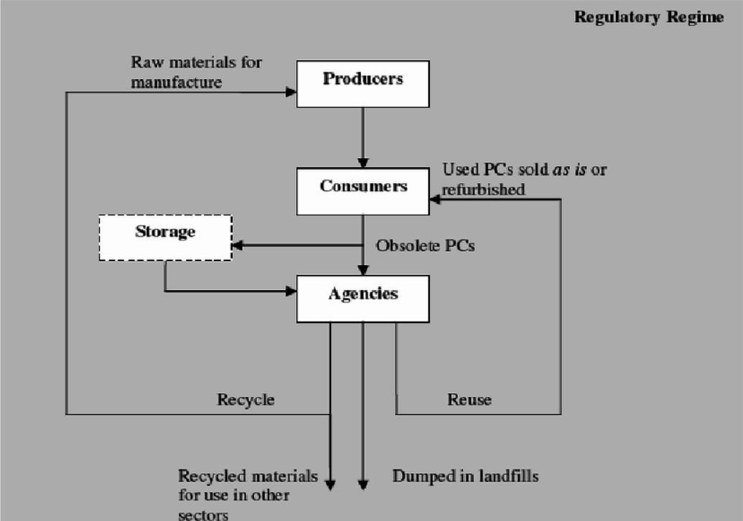

Fig No 3.1

## Database Tables

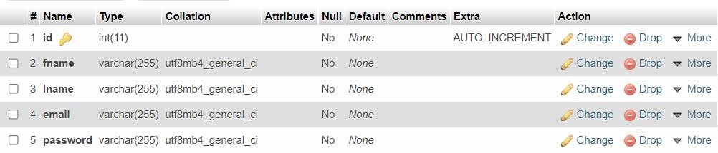**3.2.1** **ADMIN**

Fig No 3.2.1

## 3.2.2 Contact-Us

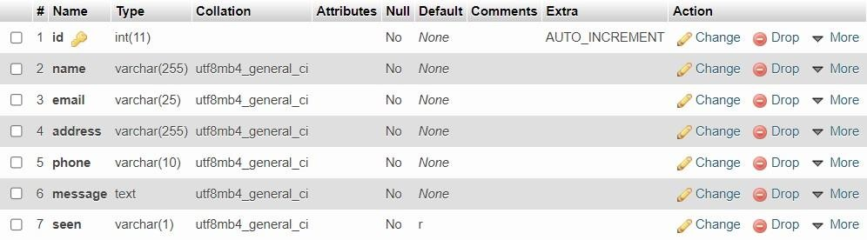

Fig No 3.2.2

**3.2.3 COUPONS**

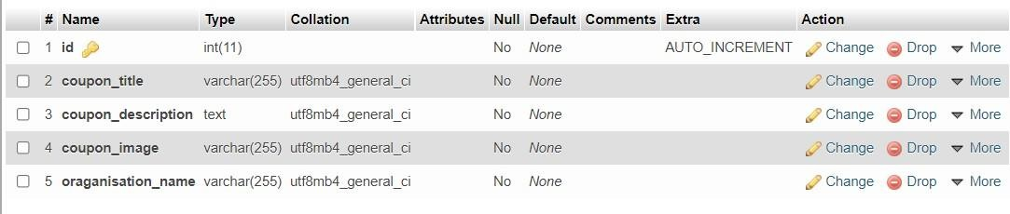

Fig No 3.2.3

## 3.2.4 REQUEST

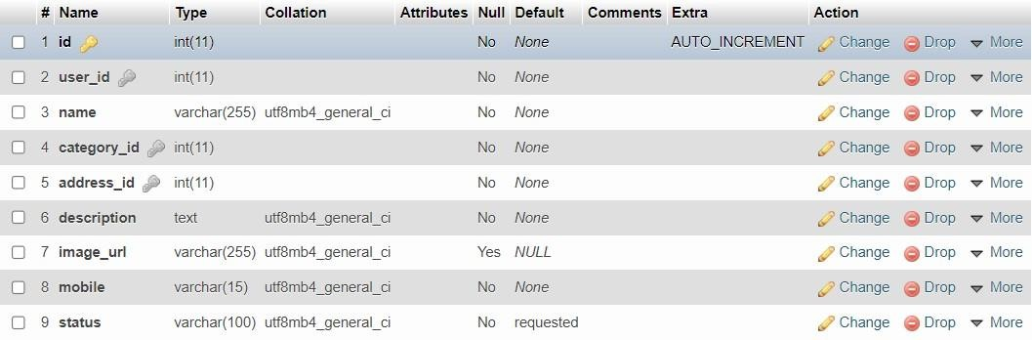

Fig No 3.2.4

**3.2.5 USERS**

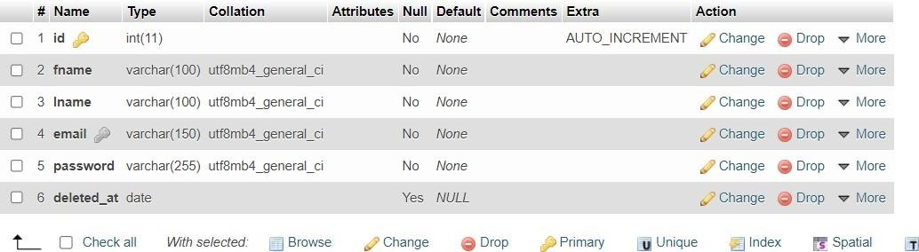Fig No 3.2.5

## Entity Relationship Diagram

* + - ER model stands for an Entity-Relationship model. It is a high-level data model. This model is used to define the data elements and relationship for a specified system.
    - It develops a conceptual design for the database. It also develops a very simple and easy to design view of data.
    - In ER modelling, the database structure is portrayed as a diagram called an entity-relationship diagram.

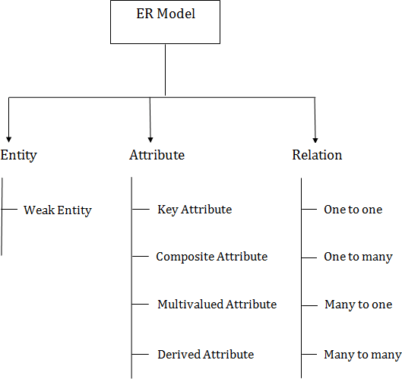

Fig No 3.3.1

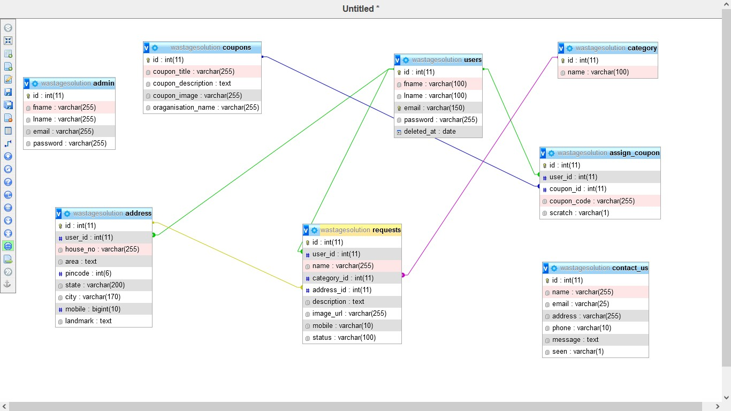

Fig No 3.3.2

## Use Case Diagram

A use case diagram is used to represent the dynamic behavior of a system. It encapsulates the system's functionality by incorporating use cases, actors, and their relationships. It models the tasks, services, and functions required by a system/subsystem of an application. It depicts the high-level functionality of a system and also tells how the user handles a system.

Following are the purposes of a use case diagram given below:

* It gathers the system's needs.
* It depicts the external view of the system.
* It recognizes the internal as well as external factors that influence the system.
* It represents the interaction between the actors.

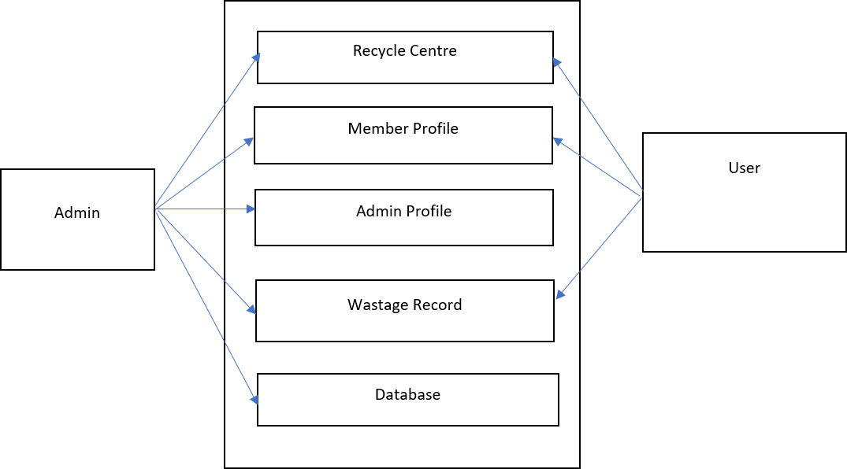

Fig No 3.4

## Sequence Diagram

The sequence diagram represents the flow of messages in the system and is also termed as an event diagram. It helps in envisioning several dynamic scenarios. It portrays the communication between any two lifelines as a time-ordered sequence of events, such that these lifelines took part at the run time. In UML, the lifeline is represented by a vertical bar, whereas the message flow is represented by a vertical dotted line that extends across the bottom of the page. It incorporates the iterations as well as branching.

### Purpose of a Sequence Diagram

To model high-level interaction among active objects within a system.

To model interaction among objects inside a collaboration realizing a use case. It either models’ generic interactions or some certain instances of interaction.

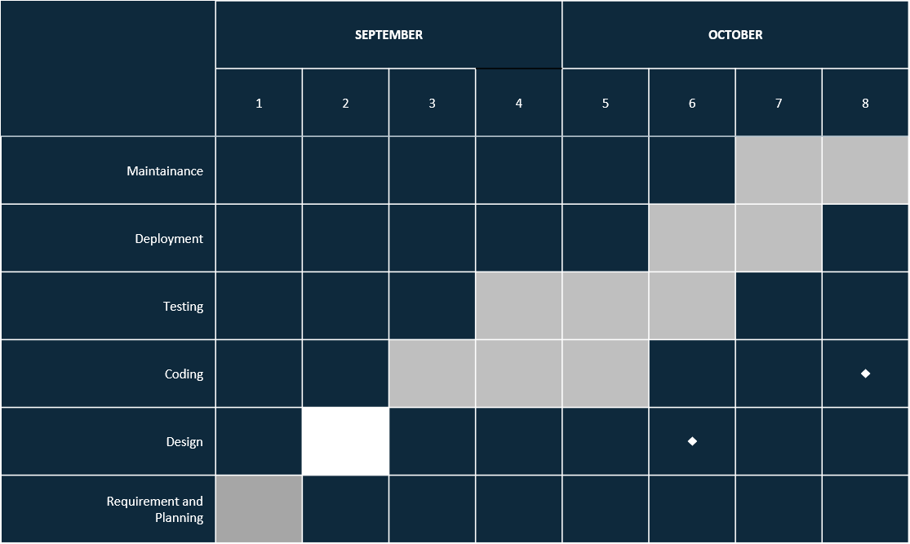

Fig No 3.5

# Chapter 4 Form Design

## Landing Page-

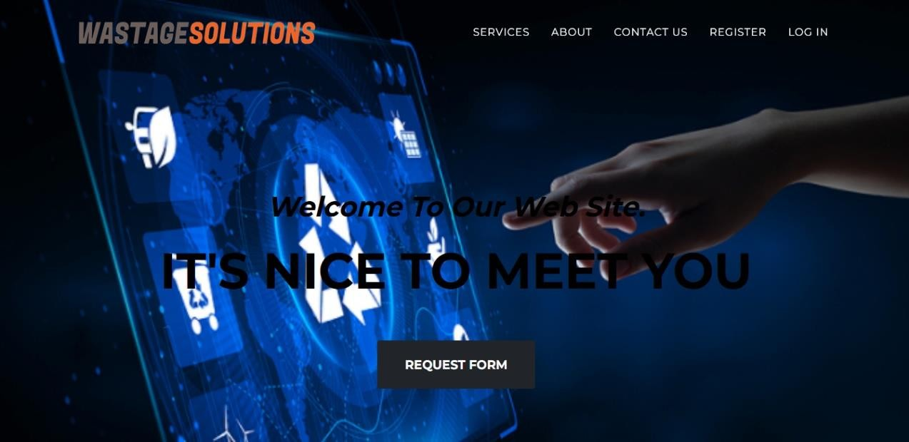

Fig No 4.1

* 1. 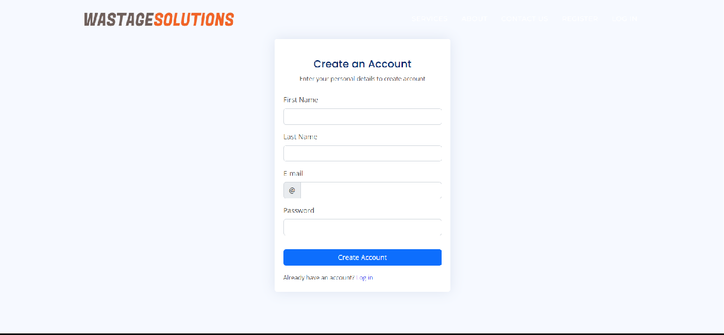**Login Page –**

Fig No 4.2.1

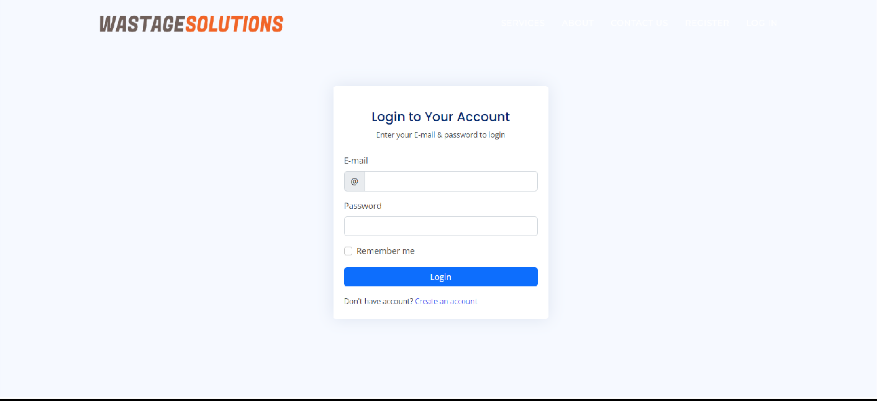

Fig No 4.2.2

## Add Request Page-

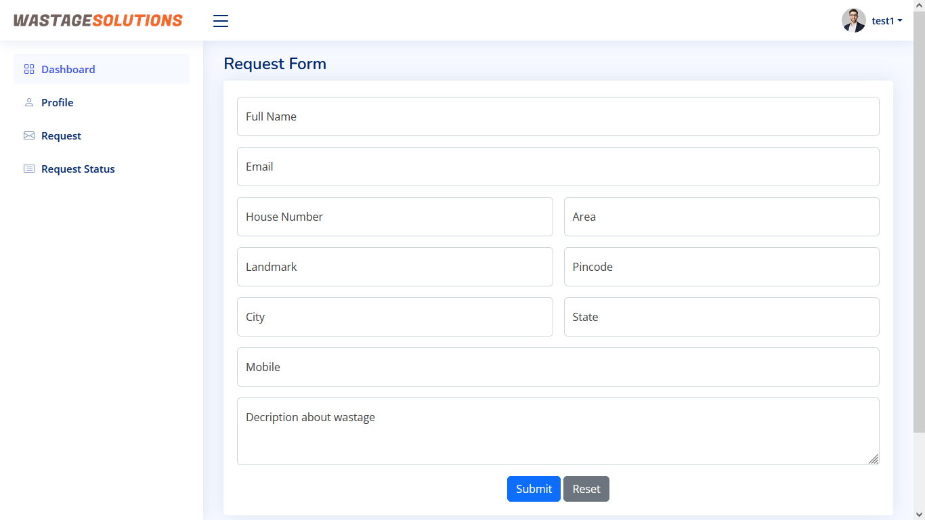

Fig No 4.3

* 1. **View request Status-**

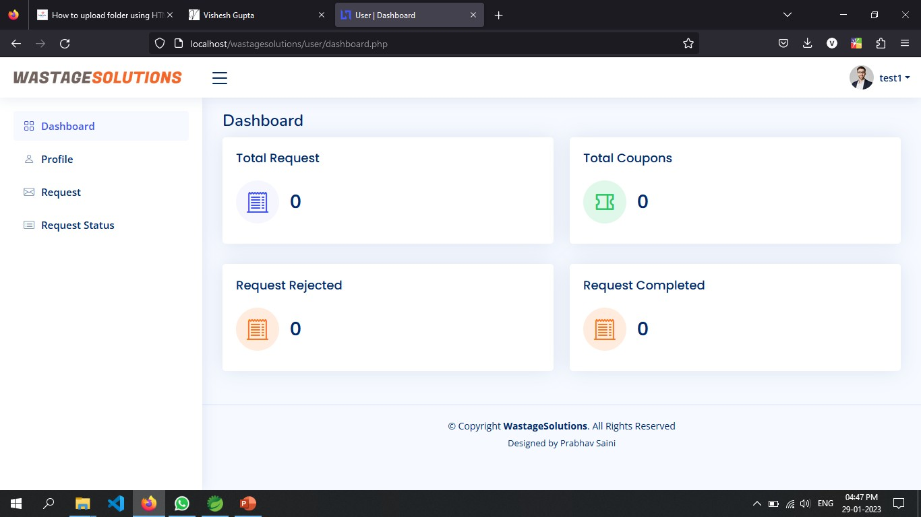

Fig No 4.4

# Chapter 5 Coding

## Login-

<!DOCTYPE html>

<html lang="en">

<head>

<meta charset="utf-8">

<meta content="width=device-width, initial-scale=1.0" name="viewport">

<title>Pages / Login - NiceAdmin Bootstrap Template</title>

<meta content="" name="description">

<meta content="" name="keywords">

<!-- Favicons -->

<link href="user/assets/img/favicon.png" rel="icon">

<link href="user/assets/img/apple-touch-icon.png" rel="apple-touch- icon">

<!-- Google Fonts -->

<link href="https://fonts.gstatic.com" rel="preconnect">

<link href="https://fonts.googleapis.com/css?family=Open+Sans:300,300i,400, 400i,6

00,600i,700,700i|Nunito:300,300i,400,400i,600,600i,700,700i|Poppins:3

00,300

i,400,400i,500,500i,600,600i,700,700i" rel="stylesheet">

<!-- Vendor CSS Files -->

<link href="user/assets/vendor/bootstrap/css/bootstrap.min.css" rel="stylesheet">

<link href="user/assets/vendor/bootstrap-icons/bootstrap-icons.css" rel="stylesheet">

<link href="user/assets/vendor/boxicons/css/boxicons.min.css" rel="stylesheet">

<link href="user/assets/vendor/quill/quill.snow.css" rel="stylesheet">

<link href="user/assets/vendor/quill/quill.bubble.css" rel="stylesheet">

<link href="user/assets/vendor/remixicon/remixicon.css"

rel="stylesheet">

<link href="user/assets/vendor/simple-datatables/style.css" rel="stylesheet">

<!-- Template Main CSS File -->

<link href="user/assets/css/style.css" rel="stylesheet">

</head>

<body>

<main>

<div class="container">

<section class="section register min-vh-100 d-flex flex-column align- items-center justify-content-center py-4">

<div class="container">

<div class="row justify-content-center">

<div class="col-lg-4 col-md-6 d-flex flex-column align-items- center justify-content-center">

w-auto">

<!-- <div class="d-flex justify-content-center py-4">

<a href="index.html" class="logo d-flex align-items-center

<img src="user/assets/img/logo.png" alt="">

<span class="d-none d-lg-block">NiceAdmin</span>

</a>

</div>End Logo -->

<div class="card mb-3">

<div class="card-body">

Your Account</h5>

<div class="pt-4 pb-2">

<h5 class="card-title text-center pb-0 fs-4">Login to

<p class="text-center small">Enter your E-mail & password to login</p>

</div>

<form class="row g-3 needs-validation" action="login.php" method="POST" novalidate>

<div class="col-12">

<label for="email" class="form-label">E-mail</label>

<div class="input-group has-validation">

<span class="input-group-text" id="inputGroupPrepend">@</span>

<input type="text" name="email" class="form- control" id="email" required>

<div class="invalid-feedback">Please enter your username.</div>

</div>

</div>

<div class="col-12">

<label for="password" class="form- label">Password</label>

<input type="password" name="password" class="form- control" id="password" required>

password!</div>

<div class="invalid-feedback">Please enter your

</div>

<div class="col-12">

<div class="form-check">

<input class="form-check-input" type="checkbox" name="remember" value="true" id="rememberMe">

<label class="form-check-label" for="rememberMe">Remember me</label>

</div>

</div>

<div class="col-12">

<button class="btn btn-primary w-100" type="submit" name="submit">Login</button>

</div>

<?php if(isset($_SESSION["alert"])){

?>

?>" id="success-alert">

<div class="<?= $_SESSION["alert"]["color_class"]

<i class="bi <?=

$_SESSION["alert"]["sign_class"] ?> me-1"></i>

<?= $_SESSION["alert"]["message"] ?>

<button type="button" class="btn-close" data- bs-dismiss="alert" aria- label="Close"></button>

</div>

<?php

} unset($_SESSION["alert"]);

?>

<div class="col-12">

<p class="small mb-0">Don't have account? <a href="register.php">Create an account</a></p>

</div>

</form>

</div>

</div>

</div>

</div>

</div>

</section>

</div>

</main><!-- End #main -->

<!-- <a href="#" class="back-to-top d-flex align-items-center justify- content-center"><i class="bi bi-arrow-up-short"></i></a> -->

<!-- Vendor JS Files -->

<script src="user/assets/vendor/apexcharts/apexcharts.min.js"></script>

<script src="user/assets/vendor/bootstrap/js/bootstrap.bundle.min.js"></script>

<script src="user/assets/vendor/chart.js/chart.min.js"></script>

<script src="user/assets/vendor/echarts/echarts.min.js"></script>

<script src="user/assets/vendor/quill/quill.min.js"></script>

<script src="user/assets/vendor/simple-datatables/simple- datatables.js"></script>

<script src="user/assets/vendor/tinymce/tinymce.min.js"></script>

<script src="user/assets/vendor/php-email-form/validate.js"></script>

<!-- Template Main JS File -->

<script src="user/assets/js/main.js"></script>

</body>

</html> Register-

<!DOCTYPE html>

<html lang="en">

<head>

<meta charset="utf-8">

<meta content="width=device-width, initial-scale=1.0" name="viewport">

<title>Pages / Login - NiceAdmin Bootstrap Template</title>

<meta content="" name="description">

<meta content="" name="keywords">

<!-- Favicons -->

<link href="user/assets/img/favicon.png" rel="icon">

<link href="user/assets/img/apple-touch-icon.png" rel="apple-touch- icon">

<!-- Google Fonts -->

<link href="https://fonts.gstatic.com" rel="preconnect">

<link href="https://fonts.googleapis.com/css?family=Open+Sans:300,300i,400, 400i,6

00,600i,700,700i|Nunito:300,300i,400,400i,600,600i,700,700i|Poppins:3

00,300

i,400,400i,500,500i,600,600i,700,700i" rel="stylesheet">

<!-- Vendor CSS Files -->

<link href="user/assets/vendor/bootstrap/css/bootstrap.min.css" rel="stylesheet">

<link href="user/assets/vendor/bootstrap-icons/bootstrap-icons.css" rel="stylesheet">

<link href="user/assets/vendor/boxicons/css/boxicons.min.css" rel="stylesheet">

<link href="user/assets/vendor/quill/quill.snow.css" rel="stylesheet">

<link href="user/assets/vendor/quill/quill.bubble.css" rel="stylesheet">

<link href="user/assets/vendor/remixicon/remixicon.css" rel="stylesheet">

<link href="user/assets/vendor/simple-datatables/style.css" rel="stylesheet">

<!-- Template Main CSS File -->

<link href="user/assets/css/style.css" rel="stylesheet">

<!--

====================================================

===

* Template Name: NiceAdmin - v2.4.1
* Template URL: https://bootstrapmade.com/nice-admin-bootstrap- admin- html-template/
* Author: BootstrapMade.com
* License: https://bootstrapmade.com/license/

====================================================

==== -->

</head>

<body>

<main>

<div class="container">

<section class="section register min-vh-100 d-flex flex-column align- items- center justify-content-center py-4">

<div class="container">

<div class="row justify-content-center">

<div class="col-lg-4 col-md-6 d-flex flex-column align-items-center justify-content-center">

auto">

<!-- <div class="d-flex justify-content-center py-4">

<a href="index.html" class="logo d-flex align-items-center w-

<img src="assets/img/logo.png" alt="">

<span class="d-none d-lg-block">NiceAdmin</span>

</a>

</div>End Logo -->

<div class="card mb-3">

<div class="card-body">

<div class="pt-4 pb-2">

<h5 class="card-title text-center pb-0 fs-4">Create an

Account</h5>

<p class="text-center small">Enter your personal details to create account</p>

<?php if(isset($_SESSION["alert"])){?>

<div class="<?= $_SESSION["alert"]["color_class"] ?>" id="success- alert">

me-1"></i>

<i class="bi <?= $_SESSION["alert"]["sign_class"] ?>

<?= $_SESSION["alert"]["message"] ?>

<button type="button" class="btn-close" data-bs-

dismiss="alert" aria-label="Close"></button>

</div>

<?php } unset($_SESSION["alert"])?>

<form class="row g-3 needs-validation" action ="signup.php" method="POST" novalidate>

<div class="col-12">

<label for="fname" class="form-label">First Name</label>

<input type="text" name="fname" class="form-control" id="fname" required>

<div class="invalid-feedback">Please, enter your name!</div>

</div>

<div class="col-12">

<label for="lname" class="form-label">Last Name</label>

<input type="text" name="lname" class="form-control" id="lname" required>

<div class="invalid-feedback">Please, enter your name!</div>

Email</label>

</div>

<!-- <div class="col-12">

<label for="yourEmail" class="form-label">Your

<input type="email" name="email" class="form-control" id="yourEmail" required>

<div class="invalid-feedback">Please enter a valid Email adddress!</div>

</div> -->

<div class="col-12">

<label for="email" class="form-label">E-mail</label>

<div class="input-group has-validation">

<span class="input-group-text" id="inputGroupPrepend">@</span>

<input type="text" name="email" class="form-control" id="email" required>

<div class="invalid-feedback">Please choose a username.</div>

</div>

<div class="col-12">

<label for="password" class="form-label">Password</label>

<input type="password" name="password" class="form-control" id="password" required>

<div class="invalid-feedback">Please enter your password!</div>

</div>

<div class="col-12">

<!-- <div class="form-check">

<input class="form-check-input" name="terms" type="checkbox" value="" id="acceptTerms" required>

<label class="form-check-label" for="acceptTerms">I agree and accept the <a href="#">terms and conditions</a></label>

<div class="invalid-feedback">You must agree before submitting.</div>

</div> -->

</div>

<div class="col-12">

<button class="btn btn-primary w-100" type="submit" name="submit"

>Create Account</button>

</div>

<div class="col-12">

<p class="small mb-0">Already have an account? <a href="regLog.php">Log in</a></p>

</div>

</form>

</div>

</div>

## Request Form-

<title>Request Form</title>

<link rel="stylesheet" type="" href="css/style.css">

</head>

<!-- Header Section Ends -->

<body>

<!-- Navbar Starts -->

<?php require("components/navbar.inc.php"); ?>

<!-- Navbar Ends -->

<?php

// session_start(); if(isset($_SESSION["user"])){

$duration=$_SESSION["user"]["duration"];

$start = $_SESSION["user"]["start"]; if((time()-$start)>$duration){ unset($_SESSION["user"]);

echo"<script>alert('Seesion has been expired! Please login again'); window.location='index.php'</script>";

exit();

}else{

?>

<div id="container">

<h1>&bull; REQUEST FORM &bull;</h1>

<div class="underline">

</div>

<div class="icon_wrapper">

<!-- <svg class="icon" viewBox="0 0 145.192 145.192">

<path d="M126.82,32.694c-2.804,0-5.08,2.273-5.08,5.075v2.721c- 1.462,0-2.646,1.185-

2.646,2.647v1.995 c0,1.585,1.286,2.873,2.874,2.873h20.577c1.462,0,2.646-

1.185,2.646-2.647v-3.041c0-1.009-0.816-1.825-1.823-1.825v-2.722 c0-

2.802-2.276-5.075-5.079-5.075h-1.985v-3.829c0-3.816-3.095-6.912-

6.913-

6.912h-0.589h-20.45c0-2.67-2.164-4.835-4.833-4.835H56.843c-2.67,0-

4.835,2.165-4.835,4.835H34.356v-3.384h-9.563v3.384v1.178h-

7.061v1.416c-

2.67,0.27-10.17,1.424-13.882,5.972 c-1.773,2.17-2.44,4.791-

1.983,7.793c0.463,3.043,1.271,6.346,2.128,9.841c2.354,9.616,5.024,20.

515,0.

549,28.077 C2.647,79.44-

3.125,90.589,2.201,99.547c4.123,6.935,13.701,10.44,28.5,10.44c1.186,0

,2.405

-0.023,3.658-0.068v9.028h-0.296 c-2.516,0-4.558,2.039- 4.558,4.558v4.566h100.04v-4.564c0-2.519-2.039-4.558-4.558-4.558h-

0.297V84.631h0.297 c2.519,0,4.558-2.037,4.558-4.556v-0.009c0-

2.516-

2.039-4.556-4.556-4.556l-36.786-0.009V61.973c0-2.193-1.777-3.971-

3.972-

3.971 v-4.711h0.456c1.629,0,2.952-1.32,2.952-

2.949h14.227V34.459h1.658c2.672,0,4.834-2.165,4.834-

4.834h20.45v3.069H126.82z M34.06,75.511c-2.518,0-4.558,2.04-

4.558,4.556v0.009c0,2.519,2.042,4.556,4.558,4.556h0.296v24.12l-

0.042-

1.168 c-15.994,0.574-26.122-2.523-30.106-9.229C-

0.464,90.5,4.822,80.347,6.55,77.423c4.964-8.382,2.173-19.774-0.29-

29.825 c-0.843-3.442-1.639-6.696-2.088-9.638c-0.354-2.35,0.129-

4.3,1.484-5.958c3.029-3.714,9.509-4.805,12.076-

5.1v1.233h7.061v1.49 v2.684c-2.403,1.114-4.153,2.997-

4.676,5.237H18.15c-

0.584,0-1.056,0.474-

1.056,1.056v0.83c0,0.584,0.475,1.056,1.056,1.056h1.984 c0.561,2.18,2.304

,3.999,4.658,5.092v0.029c0,0- 2.282,20.823,16.479,22.099v1.102c0,1.177,0.955,2.133,2.133,2.133h3.2

97 c

1.178,0,2.133-0.956,2.133-2.133V50.135c0-1.177-0.955-2.132-2.133-

2.132h-

3.297c-1.178,0-2.133,0.955-2.133,2.132 c-1.575-0.235-5.532-1.17-

6.635-

4.547c2.36-1.092,4.109-2.913,4.669-5.097h1.308c0.722,0,1.309-

0.584,1.309-

1.308v-0.578 c0-0.584-0.475-1.056-1.056-1.056h-1.539c-0.542-

2.332-2.416-

4.271-4.968-5.363v-2.559h17.651c0,2.67,2.166,4.835,4.836,4.835 h2.392v15.88h13.639c0,1.629,1.321,2.949,2.951,2.949h0.899v4.711c- 2.194,0- 3.972,1.778-3.972,3.971v13.529L34.06,75.511z

M95.188,101.78c0,8.655-

7.012,15.665-15.664,15.665c-8.653,0-15.667-7.01-15.667-15.665c0-

8.647,7.014-15.664,15.667-

15.664 C88.177,86.116,95.188,93.132,95.188,101.78z M97.189,45.669h-

9.556c0-0.896-0.726-1.62-1.619-1.62H74.494 c-0.896,0-1.621,0.727-

1.621,1.62h-8.967v-11.21h33.283V45.669z"></path>

<path d="M70.865,101.78c0,4.774,3.886,8.657,8.66,8.657c4.774,0,8.657-

3.883,8.657-8.657c0-4.773-3.883-8.656-8.657-

8.656 C74.751,93.124,70.865,97.006,70.865,101.78z"></path>

</svg> -->

</div>

<form action="applyRequest.php" method="post" id="request_form">

<div class="full">

<label for="name"></label>

<input type="text" placeholder="My Name is" name="name" id="name" required>

</div>

<div class="full">

<label for="email"></label>

<input type="email" placeholder="My email is" name="email" id="email" required>

</div>

<div class="full">

<label for="mobile"></label>

<input type="text" placeholder="My number is" name="mobile" id="mobile" maxlength="10" minlength="10" required>

</div>

<!-- combined start -->

<div class="name">

<label for="house_no"></label>

<input type="text" placeholder="House number" name="house_no" id="house_no" required>

</div>

<div class="email">

<label for="area"></label>

<input type="text" placeholder="My Locality/Area is" name="area" id="area" required>

</div>

<!-- combined end -->

<!-- combined start -->

<div class="name">

<label for="landmark"></label>

<input type="text" placeholder="My landmark is" name="landmark" id="landmark" required>

</div>

<div class="email">

<label for="pincode"></label>

<input type="text" placeholder="My pincode is" name="pincode" id="pincode" maxlength="6" minlength="6" required>

</div>

<!-- combined end -->

<!-- combined start -->

<div class="name">

<label for="city"></label>

<input type="text" placeholder="My city is" name="city" id="city" required>

</div>

<div class="email">

<label for="state"></label>

<input type="text" placeholder="My state is" name="state" id="state" required>

</div>

<div class="message">

<label for="description"></label>

<textarea name="description" placeholder="Describe about Wastage." id="description" cols="30" rows="5" required></textarea>

</div>

<div class="submit">

<input type="submit" value="Send Message" id="form_button" name="submit"/>

</div>

</form><!-- // End form -->

</div><!-- // End #container -->

<!-- Footer Starts -->

<?php include("components/footer.inc.php"); ?>

<?php

}

}else{

echo"<script>alert('You have logged out! Please Sign in again.'); window.location='index.php'</script>";

exit();

}

?>

<!-- Footer Ends -->

</body>

</html>

## Admin Dashboard-

<main id="main" class="main">

<div class="pagetitle">

<h1>Dashboard</h1>

<nav>

<ol class="breadcrumb">

<li class="breadcrumb-item"><a href="index.html">Home</a></li>

<li class="breadcrumb-item active">Dashboard</li>

</ol>

</nav>

</div><!-- End Page Title -->

<section class="section dashboard">

<div class="row">

<!-- Left side columns -->

<div class="col-lg-12">

<div class="row">

<!-- Sales Card -->

<div class="col-xxl-4 col-md-6">

<div class="card info-card sales-card">

<div class="card-body">

<h5 class="card-title">Request Completed</h5>

<div class="d-flex align-items-center">

<div class="card-icon rounded-circle d-flex align- items-center justify- content-center">

<i class="bi bi-receipt-cutoff"></i>

</div>

<div class="ps-3">

<h6><?= $decoded->completed; ?></h6>

<!-- <span class="text-success small pt-1 fw- bold">12%</span> <span class="text-muted small pt-2 ps-1">increase</span> -

->

</div>

</div>

</div>

</div>

</div><!-- End Sales Card -->

<!-- Revenue Card -->

<div class="col-xxl-4 col-md-6">

<div class="card info-card revenue-card">

<div class="card-body">

<h5 class="card-title">Coupon Alloted </h5>

<div class="d-flex align-items-center">

<div class="card-icon rounded-circle d-flex align- items-center justify- content-center">

<i class="ri ri-coupon-2-line"></i>

</div>

<div class="ps-3">

<h6><?= $decoded->coupon_alloted; ?></h6>

<!-- <span class="text-success small pt-1 fw- bold">8%</span> <span class="text-muted small pt-2 ps-1">increase</span> --

>

</div>

</div>

</div>

</div>

</div><!-- End Revenue Card -->

<!-- Customers Card -->

<div class="col-xxl-4 col-xl-6">

<div class="card info-card customers-card">

<div class="card-body">

<!-- <h5 class="card-title">Customers <span>| This Year</span></h5> -

->

<h5 class="card-title">Total Request</h5>

<div class="d-flex align-items-center">

<div class="card-icon rounded-circle d-flex align- items-center justify- content-center">

<i class="bi bi-receipt-cutoff"></i>

</div>

<div class="ps-3">

<h6><?= $decoded->requests; ?></h6>

<!-- <span class="text-danger small pt-1 fw- bold">12%</span> <span class="text-muted small pt-2 ps-1">decrease</span> -

->

</div>

</div>

</div>

</div>

</div><!-- End Customers Card -->

<div class="col-xxl-4 col-xl-6">

<div class="card info-card customers-card">

<div class="card-body">

<!-- <h5 class="card-title">Customers <span>| This Year</span></h5> -

->

<h5 class="card-title">Total Coupon</h5>

<div class="d-flex align-items-center">

<div class="card-icon rounded-circle d-flex align- items-center justify- content-center">

<i class="ri ri-coupon-2-line"></i>

</div>

<div class="ps-3">

<h6><?= $decoded->total_coupon; ?></h6>

<!-- <span class="text-danger small pt-1 fw- bold">12%</span> <span class="text-muted small pt-2 ps-1">decrease</span> -

->

</div>

</div>

</div>

</div>

</div>

<div class="col-xxl-4 col-xl-6">

<div class="card info-card customers-card">

<div class="card-body">

<!-- <h5 class="card-title">Customers <span>| This Year</span></h5> -

->

<h5 class="card-title">Processing Request</h5>

<div class="d-flex align-items-center">

<div class="card-icon rounded-circle d-flex align- items-center justify- content-center">

<i class="bi bi-receipt-cutoff"></i>

</div>

<div class="ps-3">

<h6><?= $decoded->processing; ?></h6>

<!-- <span class="text-danger small pt-1 fw- bold">12%</span> <span class="text-muted small pt-2 ps-1">decrease</span> -

->

</div>

</div>

</div>

</div>

</div>

<div class="col-xxl-4 col-xl-6">

<div class="card info-card customers-card">

<div class="card-body">

<!-- <h5 class="card-title">Customers <span>| This Year</span></h5> -

->

<h5 class="card-title">Rejected Request</h5>

<div class="d-flex align-items-center">

<div class="card-icon rounded-circle d-flex align- items-center justify- content-center">

<i class="bi bi-receipt-cutoff"></i>

</div>

<div class="ps-3">

<h6><?= $decoded->rejected; ?></h6>

<!-- <span class="text-danger small pt-1 fw- bold">12%</span> <span class="text-muted small pt-2 ps-1">decrease</span> -

->

</div>

</div>

</div>

</div>

</div>

<!-- Recent Sales -->

<!-- <div class="col-12">

<div class="card recent-sales overflow-auto">

<div class="filter">

<a class="icon" href="#" data-bs-toggle="dropdown"><i class="bi bi- three-dots"></i></a>

<ul class="dropdown-menu dropdown-menu-end dropdown-menu- arrow">

Month</a></li> Year</a></li>

<li class="dropdown-header text-start">

<h6>Filter</h6>

</li>

<li><a class="dropdown-item" href="#">Today</a></li>

<li><a class="dropdown-item" href="#">This

<li><a class="dropdown-item" href="#">This

</ul>

</div>

<div class="card-body">

<h5 class="card-title">Recent Sales <span>| Today</span></h5>

minu</a></td>

<table class="table table-borderless datatable">

<thead>

<tr>

<th scope="col">#</th>

<th scope="col">Customer</th>

<th scope="col">Product</th>

<th scope="col">Price</th>

<th scope="col">Status</th>

</tr>

</thead>

<tbody>

<tr>

<th scope="row"><a href="#">#2457</a></th>

<td>Brandon Jacob</td>

<td><a href="#" class="text-primary">At praesentium

<td>$64</td>

<td><span class="badge bg-

success">Approved</span></td>

</tr>

<tr>

<th scope="row"><a href="#">#2147</a></th>

<td>Bridie Kessler</td>

<td><a href="#" class="text-primary">Blanditiis dolor omnis similique</a></td>

<td>$47</td>

<td><span class="badge bg- warning">Pending</span></td>

</tr>

<tr>

<th scope="row"><a href="#">#2049</a></th>

<td>Ashleigh Langosh</td>

<td><a href="#" class="text-primary">At recusandae consectetur</a></td>

<td>$147</td>

<td><span class="badge bg-

success">Approved</span></td>

</tr>

<tr>

<th scope="row"><a href="#">#2644</a></th>

<td>Angus Grady</td>

<td><a href="#" class="text-primar">Ut voluptatem

id earum et</a></td>

<td>$67</td>

<td><span class="badge bg- danger">Rejected</span></td>

</tr>

<tr>

<th scope="row"><a href="#">#2644</a></th>

<td>Raheem Lehner</td>

<td><a href="#" class="text-primary">Sunt similique distinctio</a></td>

<td>$165</td>

<td><span class="badge bg-

success">Approved</span></td>

</tr>

</tbody>

</table>

</div>

</div> -->

<!-- </div>End Recent Sales -->

<!-- Top Selling -->

<!-- <div class="col-12">

<div class="card top-selling overflow-auto">

<div class="filter">

<a class="icon" href="#" data-bs-toggle="dropdown"><i class="bi bi- three-dots"></i></a>

<ul class="dropdown-menu dropdown-menu-end dropdown-menu- arrow">

Month</a></li> Year</a></li>

<li class="dropdown-header text-start">

<h6>Filter</h6>

</li>

<li><a class="dropdown-item" href="#">Today</a></li>

<li><a class="dropdown-item" href="#">This

<li><a class="dropdown-item" href="#">This

</ul>

</div>

<div class="card-body pb-0">

<h5 class="card-title">Top Selling <span>| Today</span></h5>

<table class="table table-borderless">

<thead>

<tr>

<th scope="col">Preview</th>

<th scope="col">Product</th>

<th scope="col">Price</th>

<th scope="col">Sold</th>

<th scope="col">Revenue</th>

</tr>

</thead>

<tbody>

<tr>

<th scope="row"><a href="#"><img src="assets/img/product-1.jpg" alt=""></a></th>

<td><a href="#" class="text-primary fw-bold">Ut inventore ipsa voluptas nulla</a></td>

<td>$64</td>

<td class="fw-bold">124</td>

<td>$5,828</td>

</tr>

<tr>

<th scope="row"><a href="#"><img src="assets/img/product-2.jpg" alt=""></a></th>

<td><a href="#" class="text-primary fw- bold">Exercitationem similique doloremque</a></td>

<td>$46</td>

<td class="fw-bold">98</td>

<td>$4,508</td>

</tr>

<tr>

<th scope="row"><a href="#"><img src="assets/img/product-3.jpg" alt=""></a></th>

<td><a href="#" class="text-primary fw- bold">Doloribus nisi exercitationem</a></td>

<td>$59</td>

<td class="fw-bold">74</td>

<td>$4,366</td>

</tr>

<tr>

<th scope="row"><a href="#"><img src="assets/img/product-4.jpg"

alt=""></a></th>

<td><a href="#" class="text-primary fw- bold">Officiis quaerat sint rerum error</a></td>

<td>$32</td>

<td class="fw-bold">63</td>

<td>$2,016</td>

</tr>

<tr>

<th scope="row"><a href="#"><img src="assets/img/product-5.jpg" alt=""></a></th>

<td><a href="#" class="text-primary fw-bold">Sit unde debitis delectus repellendus</a></td>

<td>$79</td>

<td class="fw-bold">41</td>

<td>$3,239</td>

</tr>

</tbody>

</table>

</div>

</div>

</div>End Top Selling -->

</div>

</div><!-- End Left side columns -->

</div>

</section>

</main><!-- End #main -->

<?php include("components/footer.inc.php"); ?>

</body>

</html>

## User Dashboard-

<!DOCTYPE html>

<html lang="en">

<head>

<meta charset="utf-8">

<meta content="width=device-width, initial-scale=1.0" name="viewport">

<title>User | Dashboard </title>

<meta content="" name="description">

<meta content="" name="keywords">

<!-- Favicons -->

<link href="assets/img/favicon.png" rel="icon">

<link href="assets/img/apple-touch-icon.png" rel="apple-touch-icon">

<!-- Google Fonts -->

<link href="https://fonts.gstatic.com" rel="preconnect">

<link href="https://fonts.googleapis.com/css?family=Open+Sans:300,300i,400, 400i,6

00,600i,700,700i|Nunito:300,300i,400,400i,600,600i,700,700i|Poppins:3

00,300

i,400,400i,500,500i,600,600i,700,700i" rel="stylesheet">

<!-- Vendor CSS Files -->

<link href="assets/vendor/bootstrap/css/bootstrap.min.css" rel="stylesheet">

<link href="assets/vendor/bootstrap-icons/bootstrap-icons.css" rel="stylesheet">

<link href="assets/vendor/boxicons/css/boxicons.min.css" rel="stylesheet">

<link href="assets/vendor/quill/quill.snow.css" rel="stylesheet">

<link href="assets/vendor/quill/quill.bubble.css" rel="stylesheet">

<link href="assets/vendor/remixicon/remixicon.css" rel="stylesheet">

<link href="assets/vendor/simple-datatables/style.css" rel="stylesheet">

<!-- Template Main CSS File -->

<link href="assets/css/style.css" rel="stylesheet">

<!--

====================================================

===

* Template Name: NiceAdmin - v2.4.1
* Template URL: https://bootstrapmade.com/nice-admin-bootstrap- admin- html-template/
* Author: BootstrapMade.com
* License: https://bootstrapmade.com/license/

====================================================

==== -->

</head>

<body>

<!-- ======= Header ======= -->

<?php include("components/header.inc.php");?>

<! -- ======= Sidebar ======= -->

<?php include("components/sidebar.inc.php");>

<main id="main" class="main">

<?php if(isset($_SESSION["alert"])) {?>

<div class=" <? = $_SESSION["alert”] ["color_class"]?>" id="success- alert">

<i class="bi <? = $_SESSION["alert"]["sign_class"] ?> me-1"></i>

<? = $_SESSION["alert”] ["message"]?>

<button type="button" class="btn-close" data-bs-dismiss="alert" aria- label="Close"></button>

</div>

<?php} unset($_SESSION["alert"])?>

<div class="pagetitle">

<h1>Dashboard</h1>

</div>

<section class="section dashboard">

<div class="row">

<!-- Left side columns -->

<div class="col-lg-12">

<div class="row">

<div class="col-xxl-4 col-md-6">

<div class="card info-card sales-card">

<div class="card-body">

<h5 class="card-title">Total Request</h5>

<div class="d-flex align-items-center">

<div class="card-icon rounded-circle d-flex align- items-center justify- content-center">

<i class="bi bi-receipt-cutoff"></i>

</div>

<div class="ps-3">

<h6><? = $decoded->requests?></h6>

</div>

</div>

</div>

</div>

</div>

<div class="col-xxl-4 col-md-6">

<div class="card info-card revenue-card">

<div class="card-body">

<h5 class="card-title">Total Coupons</h5>

<div class="d-flex align-items-center">

<div class="card-icon rounded-circle d-flex align- items-center justify- content-center">

<i class="ri-coupon-2-line"></i>

</div>

<div class="ps-3">

<h6><? = $decoded->coupons ?></h6>

</div>

</div>

</div>

</div>

</div>

<div class="col-xxl-4 col-xl-6">

<div class="card info-card customers-card">

<div class="card-body">

<h5 class="card-title">Request Rejected</h5>

<div class="d-flex align-items-center">

<div class="card-icon rounded-circle d-flex align- items-center justify- content-center">

<i class="bi bi-receipt-cutoff"></i>

</div>

<div class="ps-3">

<h6><?= $decoded->rejected ?></h6>

</div>

</div>

</div>

</div>

</div>

<div class="col-xxl-4 col-xl-6">

<div class="card info-card customers-card">

<div class="card-body">

<h5 class="card-title">Request Completed</h5>

<div class="d-flex align-items-center">

<div class="card-icon rounded-circle d-flex align- items-center justify- content-center">

<i class="bi bi-receipt-cutoff"></i>

</div>

<div class="ps-3">

<h6><?= $decoded->completed ?></h6>

</div>

</div>

</div>

</div>

</div>

</div>

</div>

</div>

</section>

</main>

<?php include("components/footer.inc.php"); ?>

<script src="https://cdnjs.cloudflare.com/ajax/libs/jquery/3.3.1/jquery.min.js"></ s cript>

<script src="https://stackpath.bootstrapcdn.com/bootstrap/4.3.1/js/bootstrap.min. js "></script>

<script>

$("#success-alert").fadeTo(2000, 500).slideUp(500, function(){

$("#success-alert").slideUp(500);

});

</script>

</body>

</html>

# Chapter 6 Testing

## Testing Case 1 (Login)-

### 6.1.1 Functional Test Cases-

* + - Verify if a user will be able to login with a valid username and valid password.
    - Verify if a user cannot login with a valid username and an invalid password.
    - Verify the login page for both, when the field is blank and Submit button is clicked.
    - Verify the ‘Forgot Password’ functionality.
    - Verify the messages for invalid login.

### 6.1.2 Non-functional Security Test Cases-

* Verify the timeout functionality of the login session.
* Verify the login page by pressing ‘Back button’ of the browser. It should not allow you to enter the system once you log out.
* Verify the Login page against SQL injection attack.
* Verify the implementation of SSL certificate.
* Verify if a user should not be allowed to log in with different credentials from the same browser at the same time.

# Testing Case 2 (Add Request)-

### 6.2.1 Functional Test Cases-

* Users should be able to select the desired attributes of the product-on-product page, such as size, color, etc.
* Adding a product to the cart should be possible.
* Checking whether users can add a product to the wish list.
* Users should be able to buy the product added to the cart once the user is signed in.
* Customers shouldn’t be able to add products to the cart when it is out of inventory**.**

### 6.2.2 Non-functional Test Cases-

* All the products added to the cart should be purchasable by the user.
* Verify error message is displayed on the UI when there is a limit on the products which can be purchased.
* The error message should be displayed on the UI when shipping is unavailable to the delivery location.
* All the payment methods should be displayed, and all of the methods should be working correctly.
* Ensure email gets triggered to the email address or mobile number when the customer buys a product.
  1. **Testing Case 3 (Logout)-**

### 6.3.1 Functional Test Cases-

* Verify After successful login in Gmail click on the profile icon to check logout button is visible or not.
* Verify by Clicking on the sign-out button without an internet connection and reconnecting to the internet to check if it’s properly logout or not.
* Verify by clicking on the logout s button, after successful logout on the login screen press the back button.
* Verify, login into more than two browser or mobiles and log out from anyone from them and check all other account is properly working or all get logout.
* Verify After logout tries to re-login with the same or different account it’s allowing or not.

### 6.3.2 Non-functional Security Test Cases*-*

* Verify the logs for the login and logout sessions.
* Verify if the logs contain multiple IPs for a single ID at the same time.
* Verify if the logs contain a denial-of-service attack for the login or logout.
* Verify if the unauthorized IP makes a request for the logout.
* Verify if the log has suspicious activity.

# Chapter 7

# Literature Review

* 1. **Introduction**

Waste (Waste management) is one of the fastest-growing waste streams globally, and its management has become a significant environmental challenge. Waste management includes discarded electronic devices such as computers, televisions, and mobile phones. These devices contain hazardous materials such as lead, cadmium, mercury, and brominated flame retardants that can have adverse effects on human health and the environment. To manage this waste stream, an effective Waste management management system is required. This literature review discusses various aspects of Waste management management systems, including their challenges, solutions, and current trends.

**7.2 Challenges of Waste management**

The challenges of Waste management include inadequate infrastructure, lack of awareness, and the complex nature of electronic devices. According to, the inadequate infrastructure for Waste management is a significant challenge, particularly in developing countries. In many developing countries, there is a lack of proper collection, transportation, and disposal facilities for Waste management. Additionally, many people are not aware of the hazardous nature of electronic devices, and they dispose of them improperly. This lack of awareness has resulted in a high rate of Waste management being sent to landfills, where it can contaminate the soil and water.

**7.3 Solutions for Waste management**

Several solutions have been proposed for managing Waste management. These solutions include the implementation of Extended Producer Responsibility (EPR) programs, the development of collection and recycling infrastructure, and the promotion of sustainable consumption. According to, EPR programs make producers responsible for the end-of-life management of their products. This approach encourages producers to design products that are easier to recycle and to take responsibility for the disposal of their products. The development of collection and recycling infrastructure is also crucial for effective Waste management. This infrastructure should include collection points, transportation, and recycling facilities. Finally, promoting sustainable consumption involves reducing the amount of Waste management generated by encouraging people to use products for a more extended period.

**7.4 Current trends in Waste management management**

Current trends in Waste management include the adoption of circular economy principles, the use of innovative technologies, and the development of international regulations. According to, the circular economy principles involve designing products for repair, reuse, and recycling. This approach aims to reduce the amount of waste generated and ensure that the resources used in product manufacturing are conserved. Innovative technologies such as artificial intelligence (AI) and the Internet of Things (IoT) are also being used to improve Waste management. For example, AI can be used to identify and sort Waste management, while IoT can be used to track the movement of Waste management from collection to disposal. Finally, international regulations such as the Basel Convention on the Control of Transboundary Movements of Hazardous Wastes and their Disposal have been developed to control the movement of Waste management across borders.

## 7.5 Conclusion

Waste management management is a significant environmental challenge that requires a comprehensive and effective management system. The challenges of Waste management include inadequate infrastructure, lack of awareness, and the complex nature of electronic devices. To address these challenges, solutions such as EPR programs, the development of collection and recycling infrastructure, and the promotion of sustainable consumption have been proposed. Current trends in Waste management include the adoption of circular economy principles, the use of innovative technologies, and the development of international regulations. A combination of these solutions and trends can lead to an effective Waste management system that reduces the negative impact of Waste management on the environment and human health.

**7.6 References**

Shah, K. U., Nnorom, I. C., & Idris, O. (2015). Waste (Waste management): An overview on generation, collection, legislation and recycling practices. Renewable and Sustainable Energy Reviews, 47

# Chapter 8 Bibliography

* PHP 8.0 and spring boot 3.0.2 – Modern Cross-Platform Development: Build applications with spring boot, Spring boot, Entity Framework Core, and PHP using Visual Studio Code, 4th Edition.
* C. J. Date, A. Kannan, and S. Swaminathan, An Introduction to Database Systems, Pearson Education, Eighth Edition, 2009.
* Abraham Silber Schatz, Henry F. Korte and S. Sudarshan, Database System Concepts, McGraw-Hill Education (Asia), Fifth Edition, 2006.
* Pressmen, Somerville, Software Engineering: Design, Implementation, and Management.

Applications

* [www.google.com](http://www.google.com/)
* [www.stackoverflow.com](http://www.stackoverflow.com/)
* [www.w3school.com](http://www.w3school.com/)
* [www.coderoject.com](http://www.coderoject.com/)